Sidebar

Definition:
# Source: AI Source: Provided by: [Data Path: Persons Table -> ID Column: 1, Name_En Column: Motasem Essam] -> From: [Chatgpt (GPT‑5 Mini)] on [2/12/2026]
A Sidebar is a web page component that appears on the side of the main content (usually left or right) and contains additional or supplementary information.

Simple Definition
# Source: AI Source: Provided by: [Data Path: Persons Table -> ID Column: 1, Name_En Column: Motasem Essam] -> From: [Chatgpt (GPT‑5 Mini)] on [2/12/2026]
Sidebar = a vertical section next to the main content that provides extra info, links, or tools.

What a Sidebar Usually Includes
# Source: AI Source: Provided by: [Data Path: Persons Table -> ID Column: 1, Name_En Column: Motasem Essam] -> From: [Chatgpt (GPT‑5 Mini)] on [2/12/2026]
- Navigation links / menus – categories, sections, or popular pages
- Widgets – calendars, social media feeds, or advertisements
- Recent posts / popular content – quick links to other content
- Search bar (optional) – another way to find content
- Calls-to-action (optional) – subscribe, download, or promotions

Purpose of a Sidebar
# Source: AI Source: Provided by: [Data Path: Persons Table -> ID Column: 1, Name_En Column: Motasem Essam] -> From: [Chatgpt (GPT‑5 Mini)] on [2/12/2026]
- Provide additional navigation or content without cluttering the main content
- Highlight important or related information
- Improve user engagement by showing extra links or tools
- Support marketing or promotional content

Examples
# Source: AI Source: Provided by: [Data Path: Persons Table -> ID Column: 1, Name_En Column: Motasem Essam] -> From: [Chatgpt (GPT‑5 Mini)] on [2/12/2026]
- Blog → recent posts, categories, or tags in the sidebar
- E-commerce → filters like price range, brand, or category
- Educational site → links to popular tutorials or courses
- News website → trending news or sponsored content

Difference Between Sidebar and Main Content
# Source: AI Source: Provided by: [Data Path: Persons Table -> ID Column: 1, Name_En Column: Motasem Essam] -> From: [Chatgpt (GPT‑5 Mini)] on [2/12/2026]
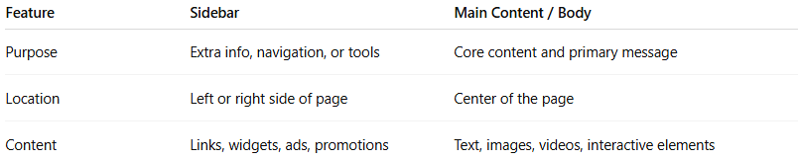
Feature | Sidebar | Main Content / Body
Purpose | Extra info, navigation, or tools | Core content and primary message
Location | Left or right side of page | Center of the page
Content | Links, widgets, ads, promotions | Text, images, videos, interactive elements

